Chemistry 141 Name
Dr. Cary Willard
Exam 1b February 22, 2011

Multiple Choice (30 points)

Page 5 (14 points)

Page 6 (14 points)

Page 7 (10 points)

Page 8 (14 points)

Page 9 (15 points)

Page 10 (15 points)

Total (112 points)

Percent (100 %)

All work must be shown to receive credit. Give all answers to the correct number of significant figures

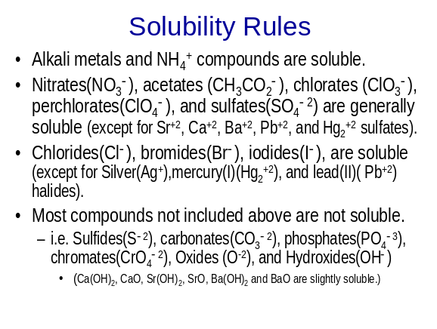Avogadros number = 6.022 x 10²³ /mol
4 quarts = 1 gallon
36 in = 1 yard

Grossmont College
Periodic Table
IA |  |  |  |  |  |  |  |  |  |  |  |  |  |  |  |  | VIIA | NOBLE GASES
1  H  1.008 | IIA |  |  |  |  |  |  |  |  |  |  |  | IIIA | IVA | VA | VIA | 1  H  1.008 | 2  He  4.002
3  Li  6.941 | 4  Be  9.012 |  |  |  |  |  |  |  |  |  |  |  | 5  B  10.81 | 6  C  12.01 | 7  N  14.01 | 8  O  16.00 | 9  F  19.00 | 10  Ne  20.18
11  Na  23.00 | 12  Mg  24.30 | IIIB | IVB | VB | VIB | VIIB | VIII VIII VIII |  |  |  | IB | IIB | 13  Al  27.00 | 14  Si  28.09 | 15  P  30.97 | 16  S  32.06 | 17  Cl  35.45 | 18  Ar  39.95
19  K  39.10 | 20  Ca  40.08 | 21  Sc  44.96 | 22  Ti  47.90 | 23  V  50.94 | 24  Cr  52.00 | 25  Mn  54.94 | 26  Fe  55.85 | 27  Co  58.93 | 28  Ni  58.70 |  | 29  Cu  63.55 | 30  Zn  65.38 | 31  Ga  69.72 | 32  Ge  72.59 | 33  As  74.92 | 34  Se  78.96 | 35  Br  79.90 | 36  Kr  83.80
37  Rb  85.47 | 38  Sr  87.62 | 39  Y  88.91 | 40  Zr  91.22 | 41  Nb  92.91 | 42  Mo  95.94 | 43  Tc  (99) | 44  Ru  101.1 | 45  Rh  102.9 | 46  Pd  106.4 | 47  Ag  107.9 |  | 48  Cd  112.4 | 49  In  114.8 | 50  Sn  118.7 | 51  Sb  121.8 | 52  Te  127.6 | 53  I  126.9 | 54  Xe  131.3
55  Cs  132.9 | 56  Ba  137.3 | 57  La  138.9 | 72  Hf  178.5 | 73  Ta  180.9 | 74  W  183.9 | 75  Re  186.2 | 76  Os  190.2 | 77  Ir  192.2 | 78  Pt  195.1 | 79  Au  197.0 |  | 80  Hg  200.6 | 81  Tl  204.4 | 82  Pb  207.2 | 83  Bi  209.0 | 84  Po  (209) | 85  At  (210) | 86  Rn  (222)
87  Fr  (223) | 88  Ra  226.0 | 89  Ac  227.0 | 104  Rf  (261) | 105  Db  (262) | 106  Sg  (263) | 107  Bh  (262) | 108  Hs  (265) | 109  Mt  (266) | 110  ??  (269)

58  Ce  140.1 | 59  Pr  140.9 | 60  Nd  144.2 | 61  Pm  (147) | 62  Sm  150.4 | 63  Eu  152.0 | 64  Gd  157.3 | 65  Tb  158.9 | 66  Dy  162.5 | 67  Ho  164.9 | 68  Er  167.3 | 69  Tm  168.9 | 70  Yb  173.0 | 71  Lu  175.0
90  Th  232.0 | 91  Pa  231.0 | 92  U  238.0 | 93  Np  (237) | 94  Pu  (244) | 95  Am  (243) | 96  Cm  (247) | 97  Bk  (247) | 98  Cf  (251) | 99  Es  (252) | 100  Fm  (257) | 101  Md  (258) | 102  No  (259) | 103  Lr  (260)

Lanthanide series

Actinide series
Multiple Choice (30 points) – Give the best answer for each of the following questions.

- A consistent explanation of known observations is called

  - an experiment.
  - a prediction.
  - a theory.
  - a hypothesis.

- Which of the following statements does not describe a chemical property of oxygen?
  - When coal is burned in oxygen, the process is called combustion.
  - Iron will rust in the presence of oxygen.
  - Oxygen combines with carbon to form carbon dioxide gas.
  - The pressure is caused by collision of oxygen molecules with the sides of a container.

- A student measured the diameter of a sphere and determined the average value. His measurements are 6.17cm, 6.16cm, 6.16cm and 6.17cm If the true diameter is 6.18 cm, what can be said about the student's results?
  - It is accurate and precise.
  - It is precise but not accurate.
  - It is accurate but not precise.
  - It is neither precise nor accurate.
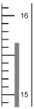
- To the correct number of significant figures, what is the temperature reading on the following Celsius thermometer?

  - 15ºC
  - 16 ºC
  - 15.67 ºC
  - 15.6 ºC

- Which of the following is not explained by Dalton's atomic theory?
  - the law of multiple proportions
  - conservation of mass during a chemical reaction
  - the existence of more than one isotope of an element
  - the law of definite proportions

- How many protons (p) and neutrons (n) are in an atom of calcium-46?
  - 20 p, 26 n
  - 26 p, 20 n
  - 46 p, 60 n
  - 20 p, 46 n

- In which set do all elements tend to form cations in binary ionic compounds?
  - Li, B, O
  - O, F, Cl
  - N, As, Bi
  - Mg, Cr, Pb

- The solid compound, Na2CO3, contains
  - Na+ ions and CO32-ions.
  - Na+, C4+, and O2- ions.
  - Na2CO3 molecules.
  - Na2+ and CO32- ions.

- How many H+ ions can the acid, H2CO3, donate per molecule?

  - 0
  - 1
  - 2
  - 3

- Which one of the following statements about balanced equations is false? In a balanced reaction
  - mass must be conserved.
  - molecules must be balanced on both sides of the reaction arrow.
  - net charge must be balanced on both sides of the reaction arrow.
  - atoms must be balanced on both sides of the reaction arrow.

- Which statement about diluted solutions is false? When a solution is diluted
  - the concentration of the solution decreases.
  - the number of moles of solvent remains unchanged.
  - the number of moles of solute remains unchanged.
  - the molarity of the solution decreases.

- HBr, HCl, HClO4, KBr, and NaCl are all classified as

  - weak electrolytes.
  - acids.
  - strong electrolytes.
  - nonelectrolytes.

- What reagent could be used to separate Br- from NO3- when added to an aqueous solution containing both?
  - NaI (aq)
  - Ba(OH)2 (aq)
  - AgNO3 (aq)

  - CuSO4 (aq)
- What is the oxidation number of the oxygen atom in H2O2?

  - +2
  - +1
  - -1
  - -2

- Which species functions as the oxidizing agent in the following reduction-oxidation reaction:
5 Fe⁺²(aq) + MnO₄⁻¹(aq) + 8 H⁺¹(aq) → Mn⁺²(aq) + 5 Fe⁺³(aq) + 4 H₂O(aq)
  - Mn2+(aq)
  - MnO4-(aq)
  - H+(aq)
  - Fe2+(aq)
Problems

- (5 points) Give the IUPAC name for the following compounds

  - MgCl₂ magnesium chloride

  - AlPO₃ aluminum phosphite

  - Cl₂O₇ dichorine heptoxide

  - KBrO₂ potassium bromite

  - V(NO₂)₅ vanadium(V) nitrite

- (5 points) Write the correct formula for each of the following compounds

  - Ammonium hypochlorite NH₄ClO

  - Zinc iodide ZnI₂

  - Ferric sulfate Fe₂(SO₄)₃

  - Mercury(I) carbonate Hg₂CO₃

  - Sulfur trioxide SO₃

- (4 points) Perform the following calculation and report your answer with the correct number of significant figures.

- (8 points) Copper can be drawn into thin wires. How many meters of 34 gauge wire (diameter = 6.304 x 10⁻³ in) can be produced from the 5.01 lb of covallite, an ore of copper that is 66.0% copper by mass (Hint: Treat the wire as a cylinder: the density of copper is 8.95 g/cm³, figure out the mass of copper wire per unit length.)

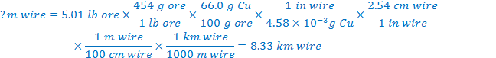

- (6 points) An element X forms both a dichloride (XCl₂) and a tetrachloride (XCl₄). Treatment of 10.00 g XCl₂ with excess chlorine forms 12.55 g XCl₄. Calculate the atomic mass of X. Predict its identity.

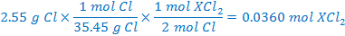

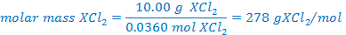

- (6 points) Complete the following double displacement reaction with balanced molecular, total ionic, and net ionic equations.

Fe(NO₃)₂(aq) + H₃PO₄(aq) →

3 Fe(NO₃)₂(aq) + 2 H₃PO₄(aq) → Fe₃(PO₄)₂(s) + 6 HNO₃(aq)

Balanced total ionic equation

3 Fe⁺²(aq) + 6 NO₃⁻¹(aq) + 2 H₃PO₄(aq) → Fe₃(PO₄)₂(s) + 6 H⁺¹(aq) + 6 NO₃⁻¹(aq)

Balanced net ionic equation

3 Fe⁺²(aq) + 2 H₃PO₄(aq) → Fe₃(PO₄)₂(s) + 6 H⁺¹(aq)

- (4 points) Balance the following redox half reaction that occurs in basic solution

SO₂Cl₂ + H₂O + 2 e⁻¹→ SO₃⁻² + 2 Cl⁻¹ + 2 H⁺¹

2 H⁺¹ + 2 OH⁻¹ → 2 H₂O
SO₂Cl₂ + 2 OH⁻¹ + 2 e⁻¹ → SO₃⁻² + 2 Cl⁻¹ + H₂O

Is this an oxidation or a reduction?

reduction
- (6 points) Balance the following redox reaction in acidic solution
S₂O₃⁻² + OCl⁻¹ → Cl⁻¹ + S₄O₆⁻²

1st half reaction

2 S₂O₃⁻² → S₄O₆⁻² + 2 e⁻¹

2nd half reaction

OCl⁻¹ + 2 H⁺¹ + 2 e⁻¹→ Cl⁻¹ + H₂O

overall reaction in acid

2 S₂O₃⁻² + OCl⁻¹ + 2 H⁺¹ → S₄O₆⁻² + Cl⁻¹ + H₂O

- (8 points) When 6.853 mg of a sex hormone containing C, H, and O was burned in a combustion analysis, 19.73 mg of CO₂ and 6.391 mg of H₂O were obtained. What is the empirical formula of the compound?

(

(10.43% H)

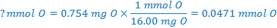

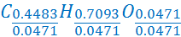

- (5 points) How many grams of copper are in 50.0 mL of a 28.7% solution of copper (II) chloride with a density of 1.284 g/mL?

- (10 points) Phencyclidine or angle dust has a molecular formula C₁₇H₂₅N. Answer the following questions regarding phencyclidine.
  - Calculate the molar mass of phencyclidine.

  - Calculate the number of moles of carbon in 6.83 moles of phencyclidine.

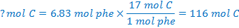

  - Calculate the number of molecules of phencyclidine that contains 325 atoms of hydrogen.

  - Calculate the mass of phencyclidine that contains 6.836 x 10²⁴ atoms of carbon.

  - Calculate the mass in grams of one molecule of phencyclidine.

- (15 points) You mix 527.0 mL of 0.2754 M sodium carbonate with 250.0 mL of 0.6684 M chromium(III) chloride. Write the reaction and determine the number of grams of chromium(III) carbonate produced, and the final concentration of all ions in the solution.

Balanced chemical equation (Check with me before you go on to be sure this is correct.)

3 Na₂CO₃(aq) + 2 CrCl₃(aq) → 6 NaCl(aq) + Cr₂(CO₃)₃(s)

 | X = 0.0484 mol |  | X=0.0836mol
 | 3 Na₂CO₄(aq) | + | 2 CrCl₃(aq) | → | 6 NaCl(aq) | + | Cr₂(CO₃)₃(s)
I | 0.1451 mol |  | 0.1671 mol |  | 0 mol |  | 0 mol
Δ | -3x |  | -2x |  | +6x |  | + x
E | 0.1451 – 3x |  | 0.1671-2x |  | 6x |  | 1x
 | =0.1451-3(.0484)  =0 mol |  | =0.1671-2(.0484)  =0.0703mol |  | =6(0.0484)  =0.2904 mol |  | =0.0484 mol
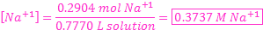
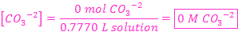
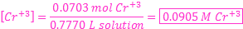

Moles Cr₂(CO₃)₃ produced 0.0484 mol Mass Cr₂(CO₃)₃ produced 13.7 g

Moles Na⁺¹ = 0.2904 mol [Na⁺¹] = 0.3737M

Moles CO₃⁻² = 0 mol [CO₃⁻²] = 0 M

Moles Cr⁺³ = 0.0703 mol [Cr⁺³] = 0.0905 M

Moles Cl⁻¹ = 0.5013 mol [Cl⁻¹] = 0.6452 M

